Copying Files using SSH

**if you don’t know the full pathname for your file in iLab, use the command “pwd”

**purple = what you want to copy (source); green = location you want to copy to (destination)

**Copying from iLab to Windows (assuming you have PuTTY)**

In the Windows cmd:

pscp -r netid@[iLab name].cs.rutgers.edu:/iLab/users/netid/… C:\Users…

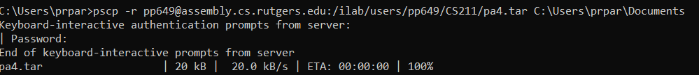

**Copying from Windows to iLab (assuming you have PuTTY)**

In the Windows cmd:

Just switch order:

pscp -r C:\Users… netid@[iLab name].cs.rutgers.edu:/iLab/users/netid/…

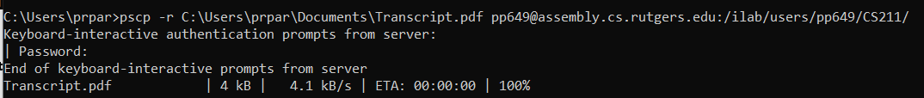

I now have Transcript.pdf in my CS211 directory in iLab



**Mac**

The commands are essentially the same, you just need to know the pathname for the file it is you are transferring and the pathname of your destination. Instead of using pscp (which is specific for PuTTY users), use scp.

For example:

scp pp649@assembly.cs.rutgers.edu:/ilab/users/pp649/CS211/pa4.tar /Users/Priya/local/...